**Assignment 3**

**CEE 598**

**ASU ID: 1215306430**

**Q1:**

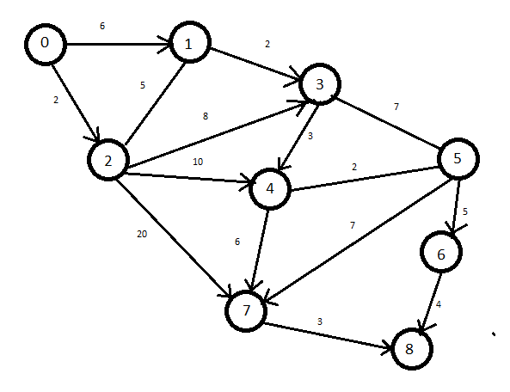

For the given network I used the Dijkstra’s Algorithm to solve it manually

The shortest path is 0-1-3-4-7-8 with the cost of 20

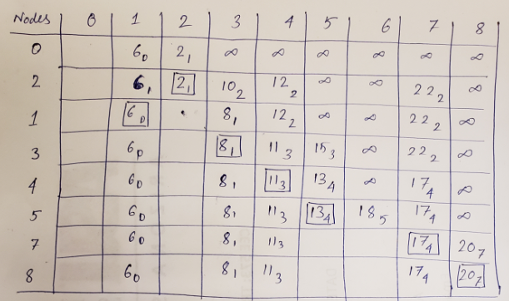

I have also solved it manually via the label correcting algorithm.

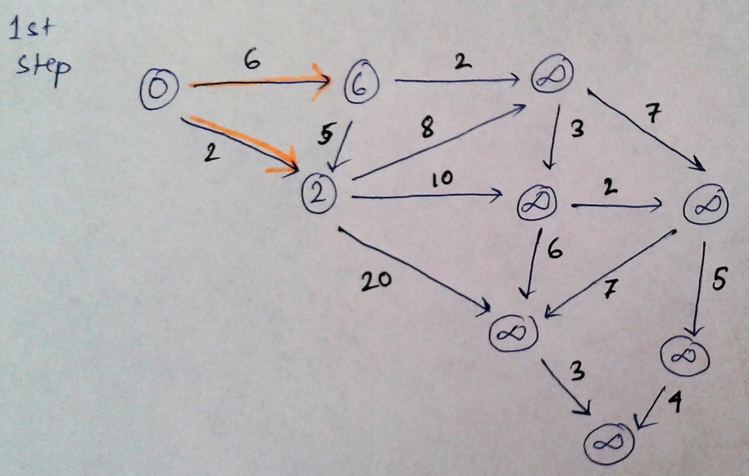

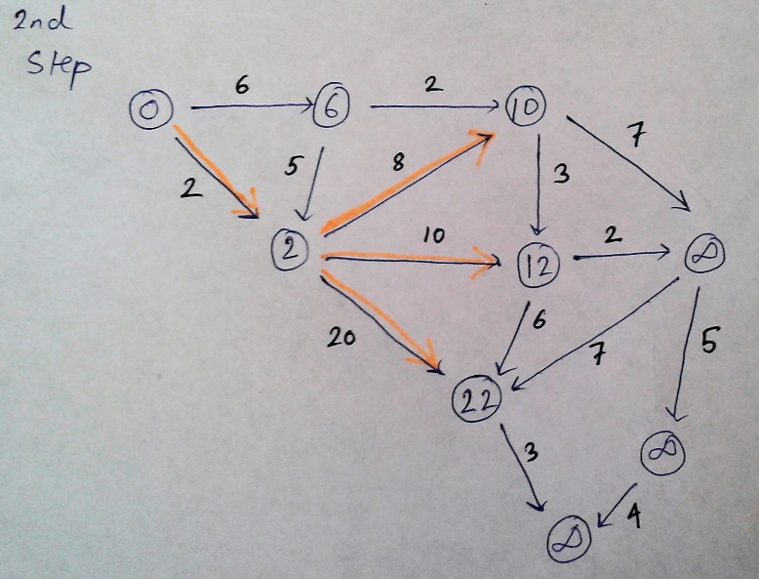

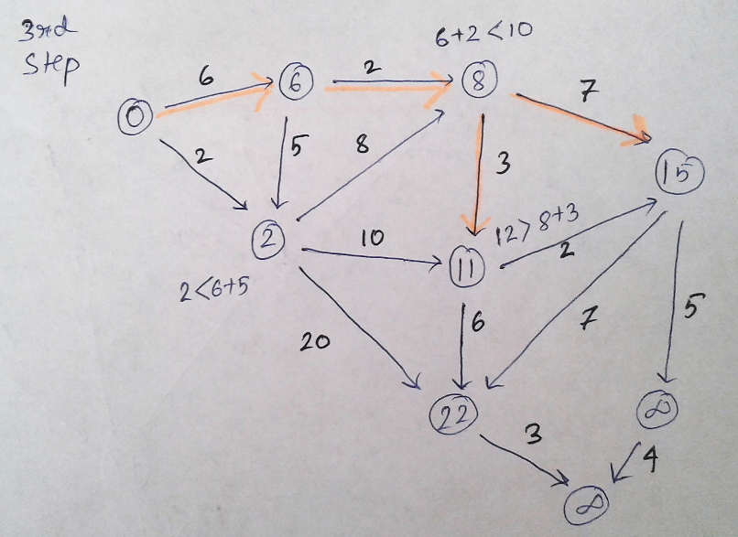

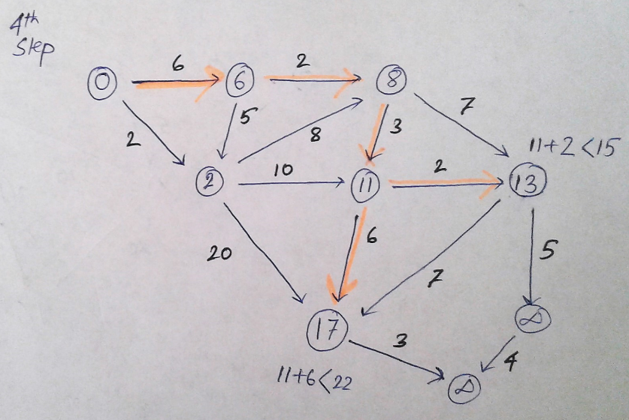

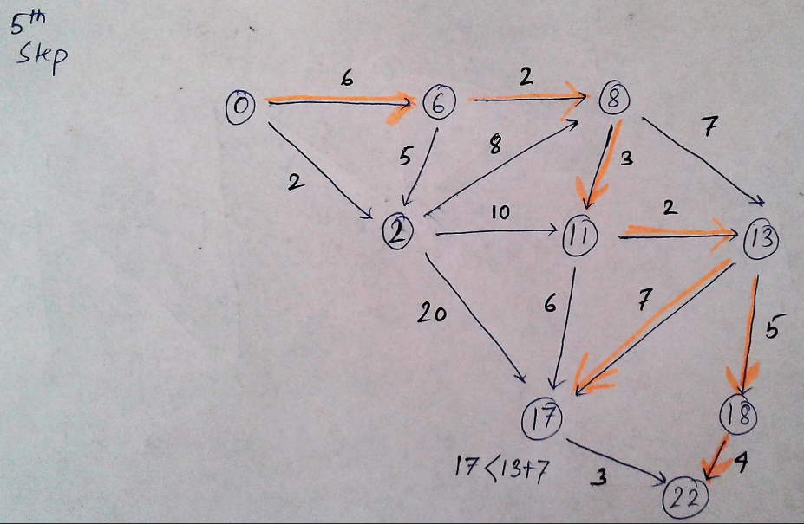

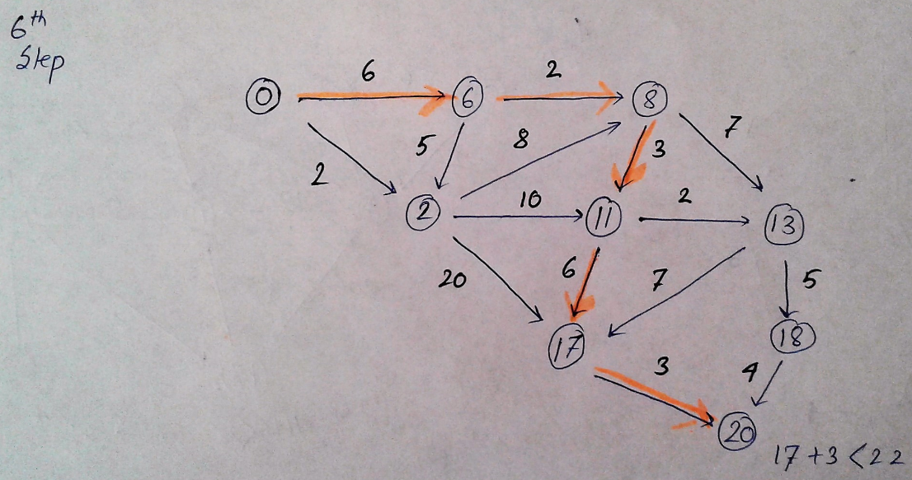

So the shortest path will follow the labels 0-6-8-11-17-20

The final cost being 20 which checks out with the Dijkstra’s Algorithm

**Q2:**

I ran the python code of label correcting algorithm to find the shortest path for the given network.

The results are as follows:-

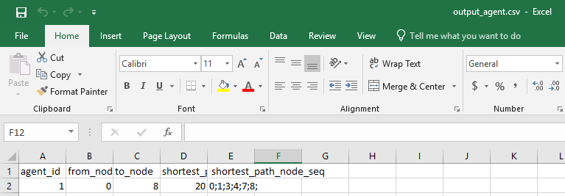

**Q3:**

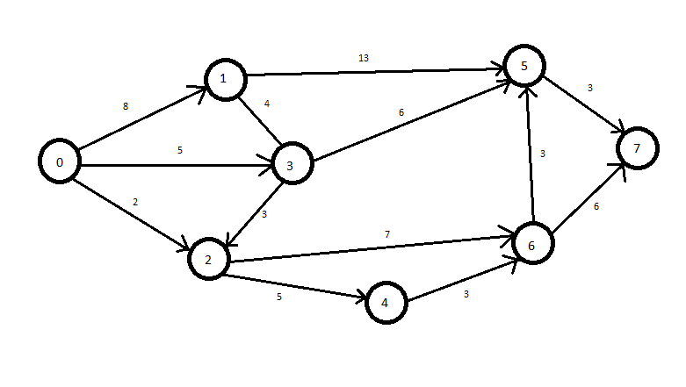

This is the network created by me. I solved it manually by using the Dijkstra’s algorithm.

The shortest path is 0-3-5-7 with the cost of 14

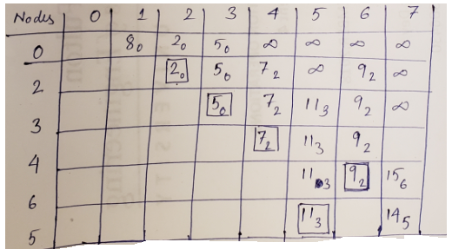

I also solved the network manually with Label correcting algorithm:-

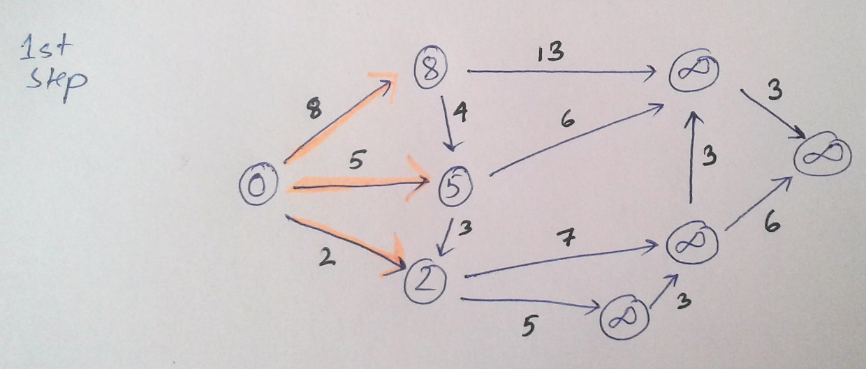

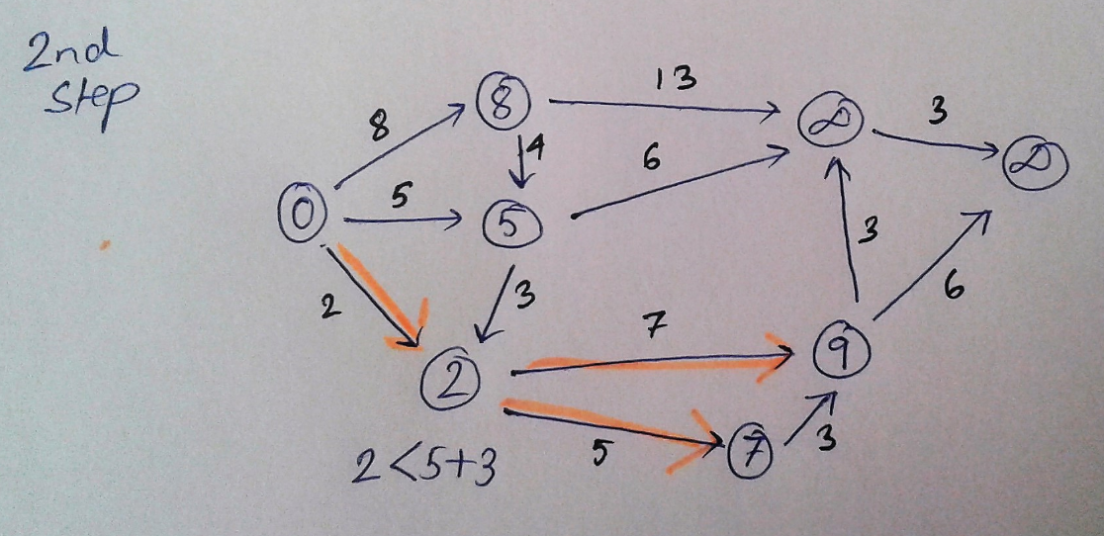

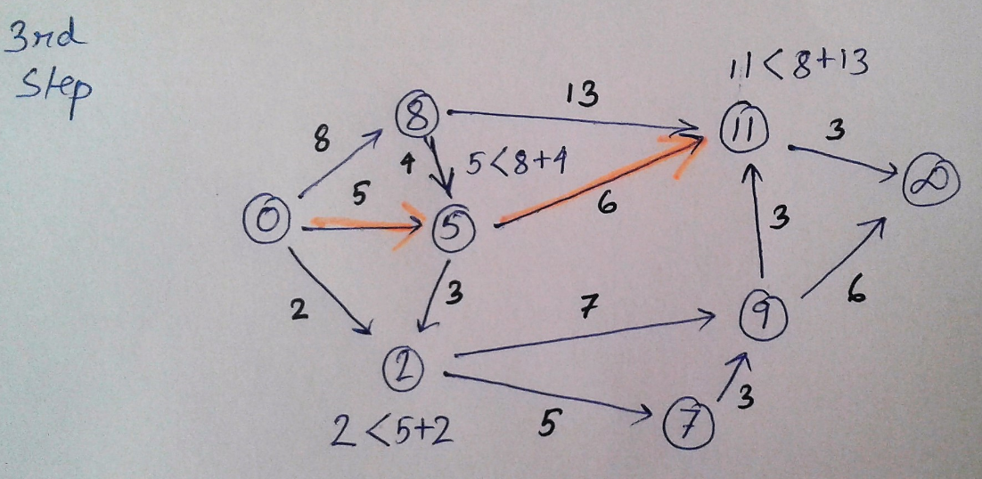

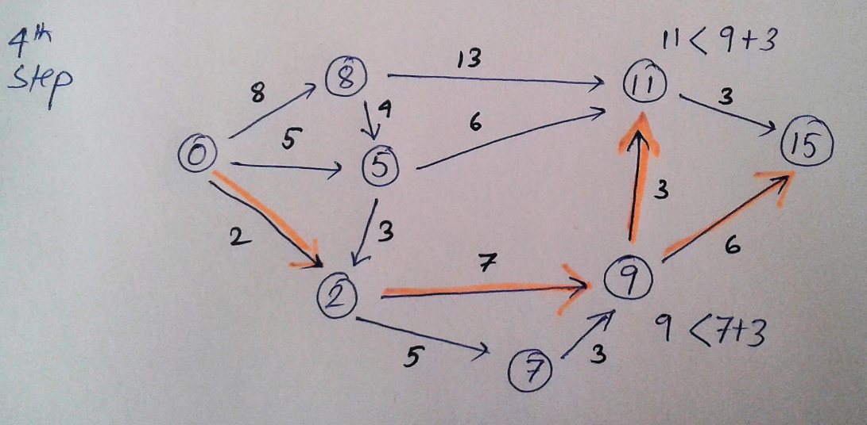

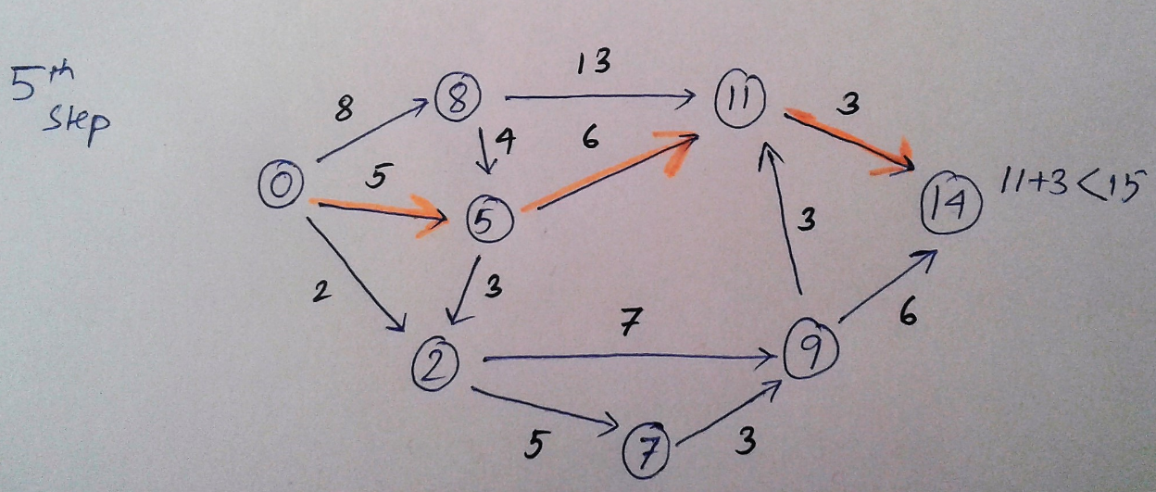

The shortest path will follow the label 0-5-11-14. So the cost is 14 following the shortest path.

I ran the python code of label correcting algorithm to find the shortest path for this created network.

The results are as follows:-

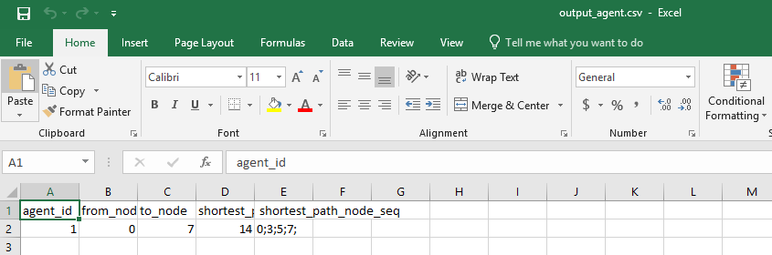

The results of the code check out with the results gotten manually.